ECOMMERCE DATA
CLEANING & EXPLORATORY DATA ANALYSIS
Comprehensive Project Report

BY: ANKIT KUMAR

1. INTRODUCTION
This report documents the data profile, data-quality checks, descriptive analysis, categorical comparisons, time-based sales trend, correlation analysis, and outlier review for an ecommerce order dataset containing 1,200 rows and 14 columns. The supplied data-quality report records 0 completely duplicated rows and 309 missing cells across the dataset.
Across the supplied records, the sum of TotalPrice is 1,264,761.96 and the mean record-level TotalPrice is 1,053.97. These are dataset-level summaries, not independently audited business results.
The supplied IQR outlier summary flags 8 TotalPrice observations and no outliers in Quantity, UnitPrice, or ItemsInCart. The correlation heatmap indicates the strongest displayed positive relationship is between UnitPrice and TotalPrice (0.72), followed by Quantity and ItemsInCart (0.65), and Quantity and TotalPrice (0.62). Correlation does not establish causation.
2. Project Objectives
- Understand the structure, variables, and coverage of the ecommerce dataset.
- Review missing values, duplicate records, data types, and numerical validity.
- Summarize numerical and categorical variables using descriptive statistics and charts.
- Compare sales across products and referral sources, and orders across statuses and payment methods.
- Examine monthly sales patterns and relationships between numerical variables.
- Identify potential outliers and provide practical recommendations for further analysis.
3. Dataset Overview
The supplied workbook contains the following fields:
Field | Role / Type | Description
OrderID | Identifier | Order reference
Date | Date/time | Date associated with the record
CustomerID | Identifier | Customer reference
Product | Categorical | Product category
Quantity | Numeric count | Units recorded in the order line
UnitPrice | Numeric measure | Price per unit
ShippingAddress | Text/address | Shipping address text
PaymentMethod | Categorical | Payment channel
OrderStatus | Categorical | Current/status label recorded
TrackingNumber | Identifier/text | Shipment tracking reference
ItemsInCart | Numeric count | Number of items in cart
CouponCode | Categorical/text | Coupon code, if present
ReferralSource | Categorical | Marketing/referral source
TotalPrice | Numeric measure | Recorded total price

4. Data Quality and Cleaning Review
4.1 Data-quality summary
Metric | Value
Total Rows | 1200
Total Columns | 14
Duplicate Rows | 0
Total Missing Values | 309
Columns With Missing Values | 1
Numerical Columns | 4
Categorical Columns | 10

The data-quality summary reports one column with missing values and 309 missing cells overall. The cleaning script checks coupon-code missingness, duplicate OrderIDs, date conversion, numeric conversion, non-positive quantities, negative prices, and whether TotalPrice matches Quantity × UnitPrice. The script also standardizes surrounding whitespace in selected text columns.
Important interpretation: missing coupon codes may represent orders that did not use a coupon, rather than data-entry errors. Missing values should be handled according to business meaning, not automatically deleted or replaced.

4.2 Outlier summary using the IQR rule
Column | Q1 | Q3 | IQR | Lower bound | Upper bound | Outlier count
Quantity | 2.00 | 4.00 | 2.00 | -1.00 | 7.00 | 0
UnitPrice | 186.06 | 521.57 | 335.51 | -317.20 | 1024.83 | 0
ItemsInCart | 4.00 | 7.00 | 3.00 | -0.50 | 11.50 | 0
TotalPrice | 410.52 | 1578.47 | 1167.95 | -1341.41 | 3330.41 | 8

The IQR method defines potential outliers as values below Q1 − 1.5×IQR or above Q3 + 1.5×IQR. The provided report identifies 8 TotalPrice outliers, all above the reported upper bound of 3,330.41. Outliers are not automatically errors: confirm them against order details and pricing rules before removing them.
5. Univariate Analysis
5.1 Numerical variables
Variable | Count | Mean | Std. dev. | Minimum | Median (50%) | Maximum
Quantity | 1200 | 2.95 | 1.41 | 1.00 | 3.00 | 5.00
UnitPrice | 1200 | 356.41 | 197.18 | 11.39 | 364.21 | 699.93
ItemsInCart | 1200 | 5.49 | 2.28 | 1.00 | 5.00 | 10.00
TotalPrice | 1200 | 1,053.97 | 819.86 | 11.39 | 823.62 | 3,456.40
The numerical summaries describe typical values and spread for Quantity, UnitPrice, ItemsInCart, and TotalPrice. Box plots are included later in this report to visualize medians, interquartile ranges, whiskers, and any marked potential outliers.
5.2 Categorical variables
Product
- Printer: 181 (15.1%)
- Tablet: 179 (14.9%)
- Chair: 178 (14.8%)
- Laptop: 173 (14.4%)
- Desk: 170 (14.2%)
- Monitor: 163 (13.6%)
- Phone: 156 (13.0%)
PaymentMethod
- Online: 258 (21.5%)
- Cash: 246 (20.5%)
- Credit Card: 234 (19.5%)
- Debit Card: 232 (19.3%)
- Gift Card: 230 (19.2%)
OrderStatus
- Cancelled: 250 (20.8%)
- Returned: 247 (20.6%)
- Pending: 237 (19.8%)
- Shipped: 235 (19.6%)
- Delivered: 231 (19.2%)
CouponCode
- FREESHIP: 313 (26.1%)
- Missing / blank: 309 (25.8%)
- WINTER15: 292 (24.3%)
- SAVE10: 286 (23.8%)
ReferralSource
- Instagram: 259 (21.6%)
- Email: 250 (20.8%)
- Google: 241 (20.1%)
- Facebook: 228 (19.0%)
- Referral: 222 (18.5%)
6. Graphical Analysis
The following figures are the actual chart files supplied with the project. Each is accompanied by a brief interpretation. Chart values are interpreted from the provided visuals and supporting reports.
Monthly Sales Trend
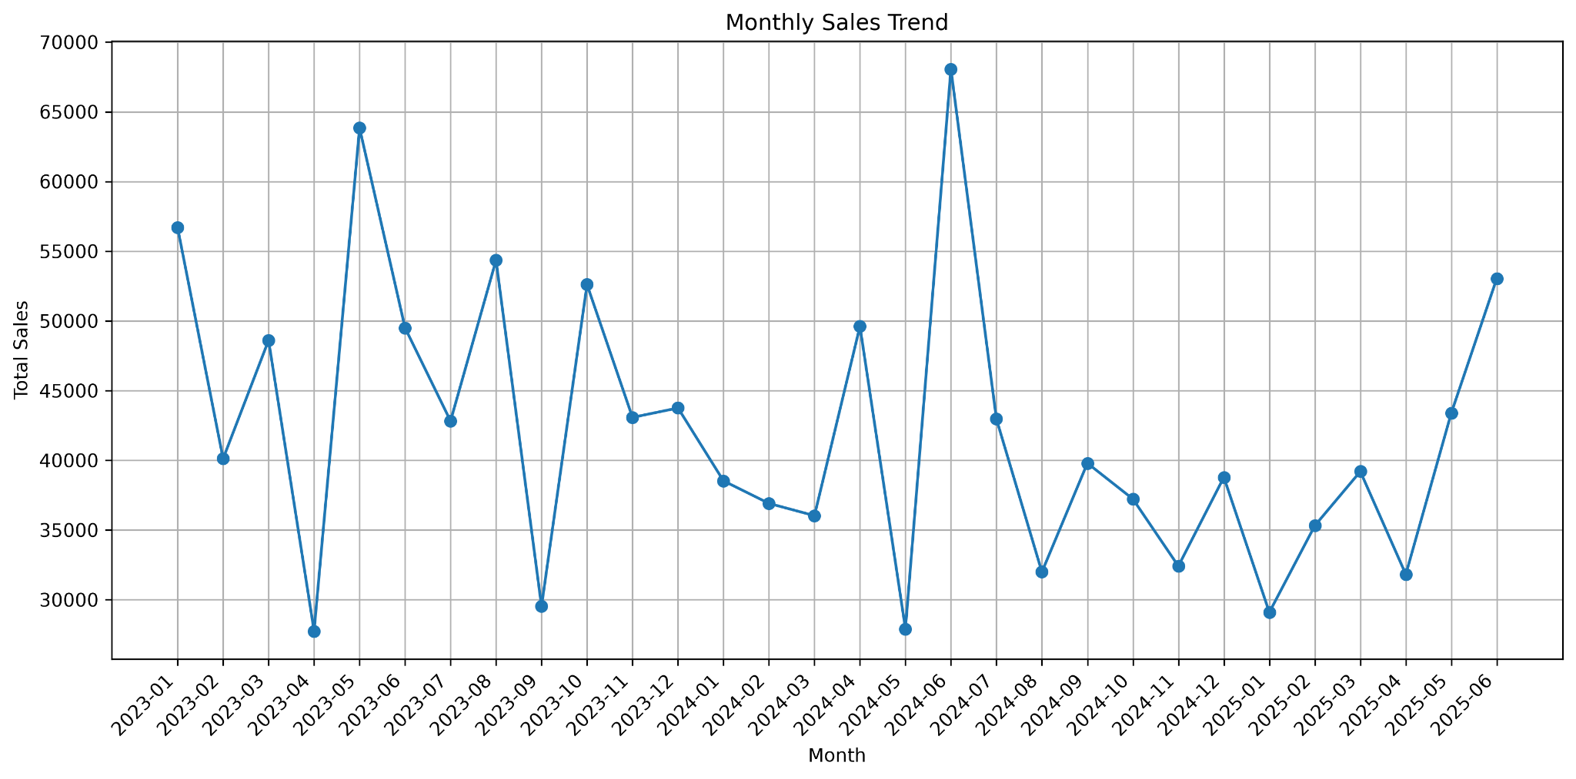
Monthly Total Price varies substantially over the displayed period (January 2023 to June 2025). The most prominent peak appears around June 2024, while several months show lower totals. Investigate seasonality, promotions, product mix, and any unusually large transactions before attributing causes.
Total Sales by Product
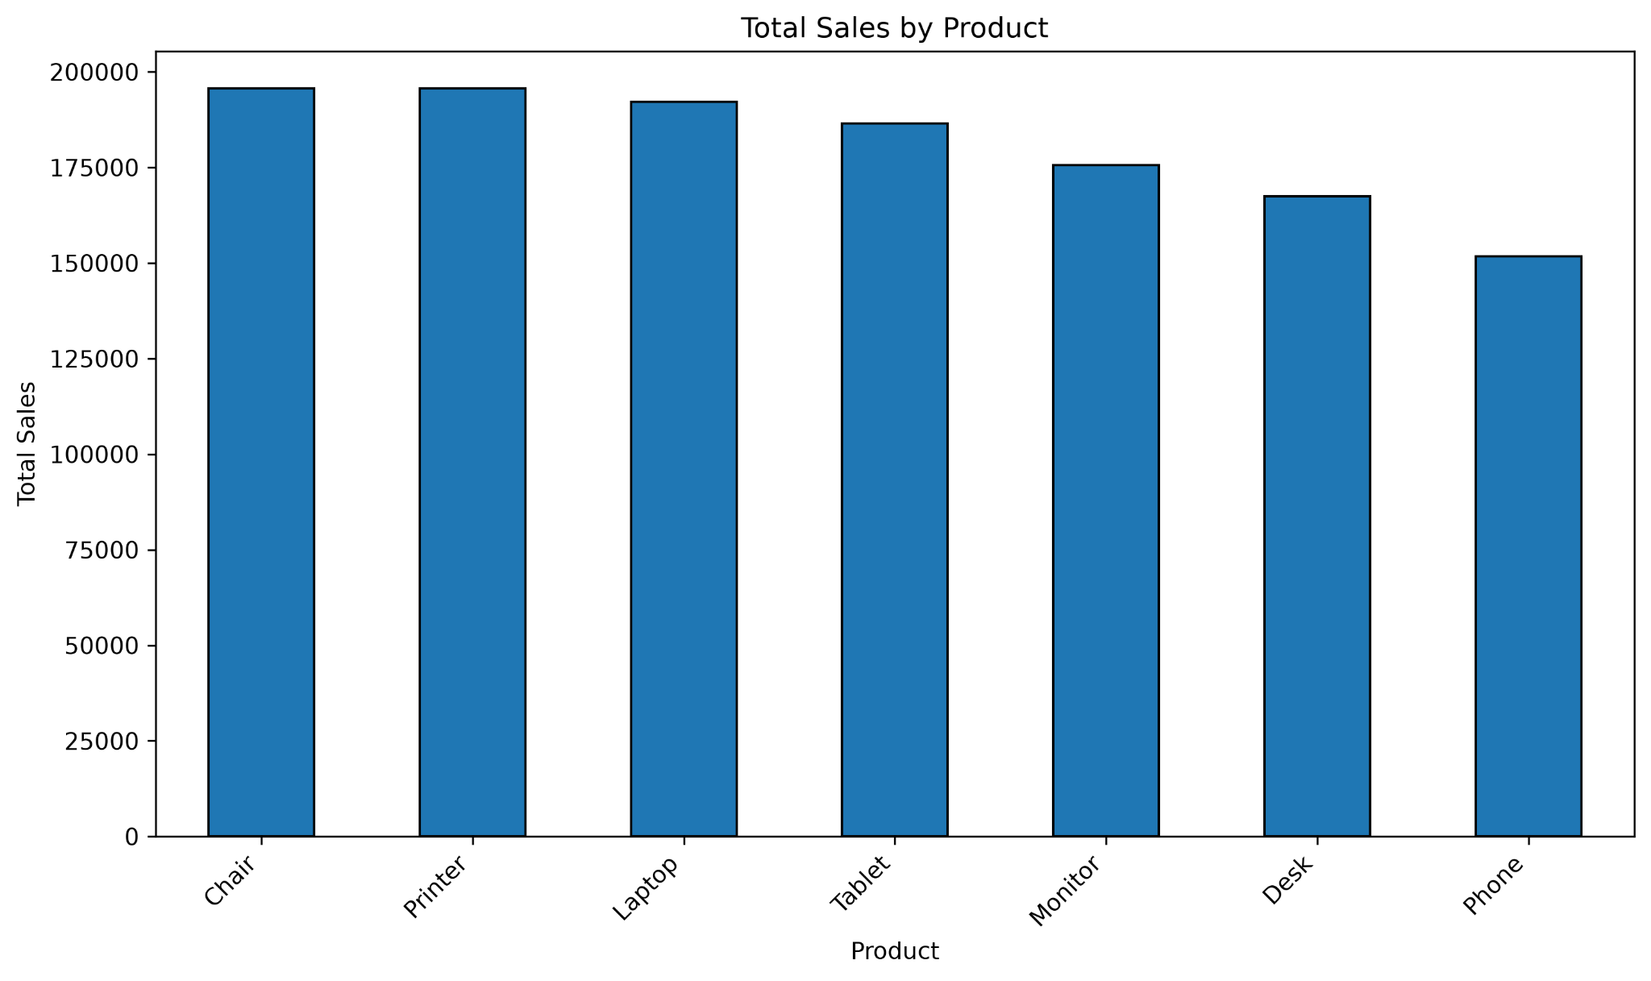
Chair and Printer are the highest-sales products in the displayed chart, followed by Laptop and Tablet. Phone is the lowest among the shown product categories. This comparison can guide inventory and product-level marketing review.
Distribution of Order Status
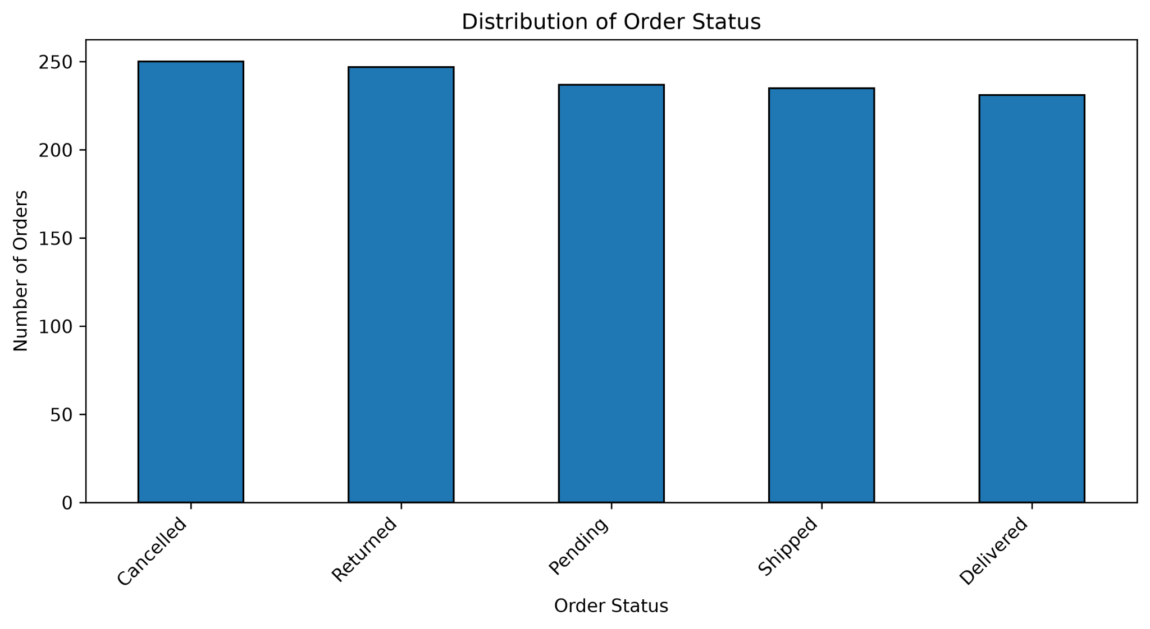
The five displayed status categories have broadly similar counts. Cancelled and Returned appear slightly more frequent than Delivered in the chart. Review cancellation and return reasons, and distinguish completed sales from cancelled or returned transactions.
Orders by Payment Method
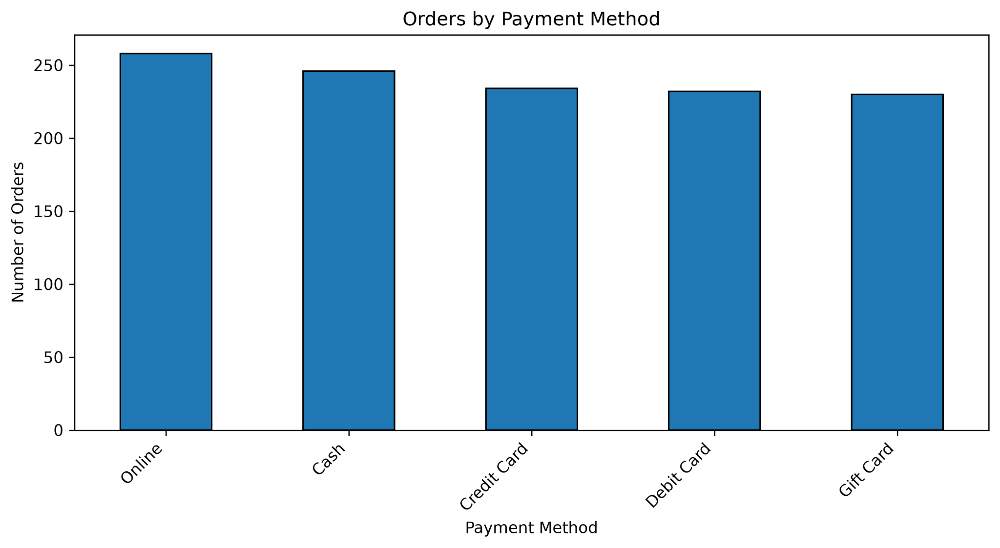
Online is the most common payment method in the chart, with Cash next. Credit Card, Debit Card, and Gift Card follow. Payment-method counts show order frequency, not necessarily revenue or profitability by payment type.
Total Sales by Referral Source
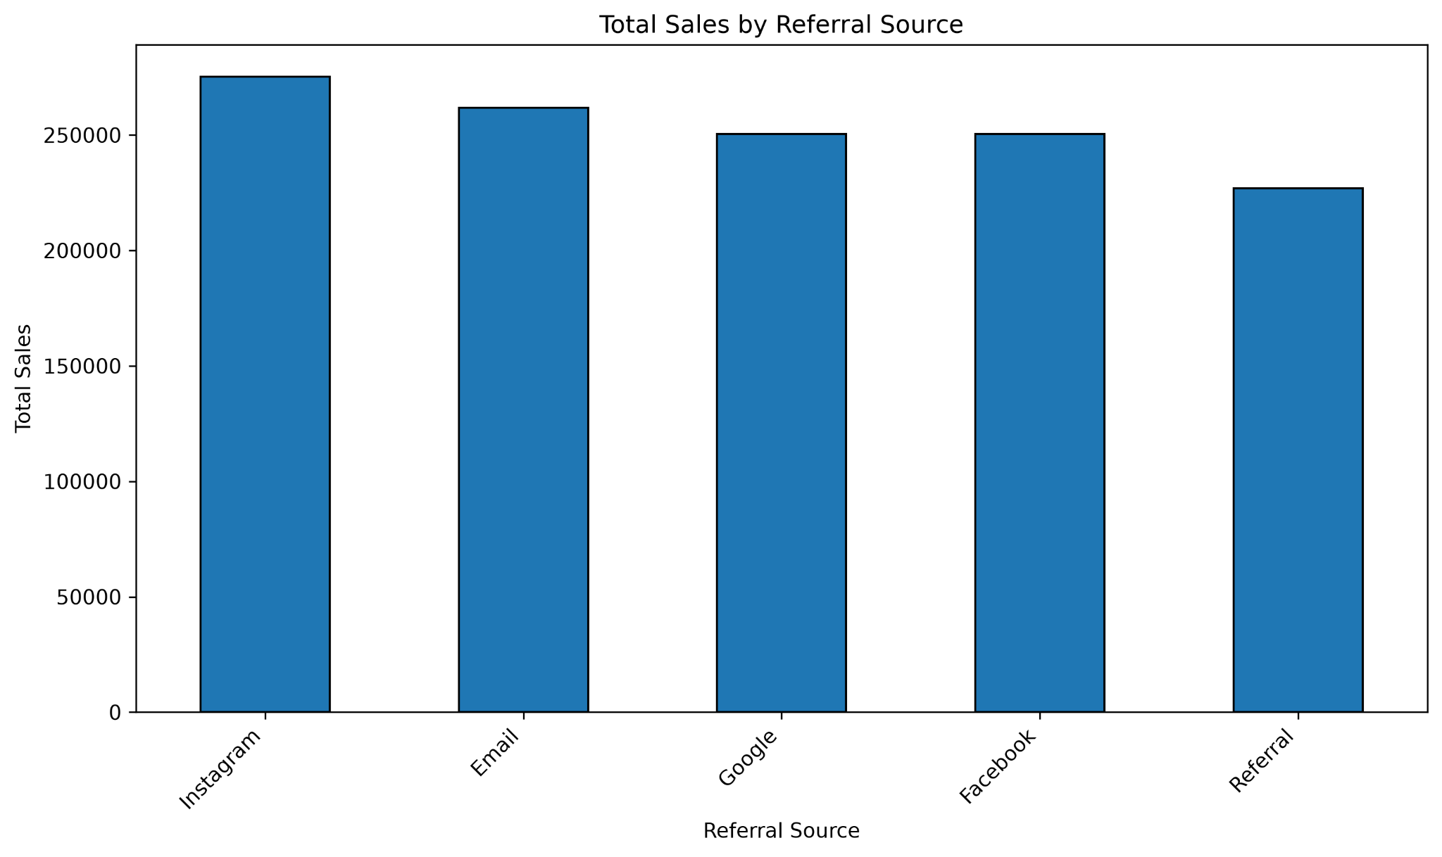Instagram has the highest displayed referral-source sales, followed by email. Google and Facebook are similar, while Referral is lower. To evaluate marketing effectiveness, compare sales with spend, conversion rate, and customer acquisition cost where available.
Correlation Heatmap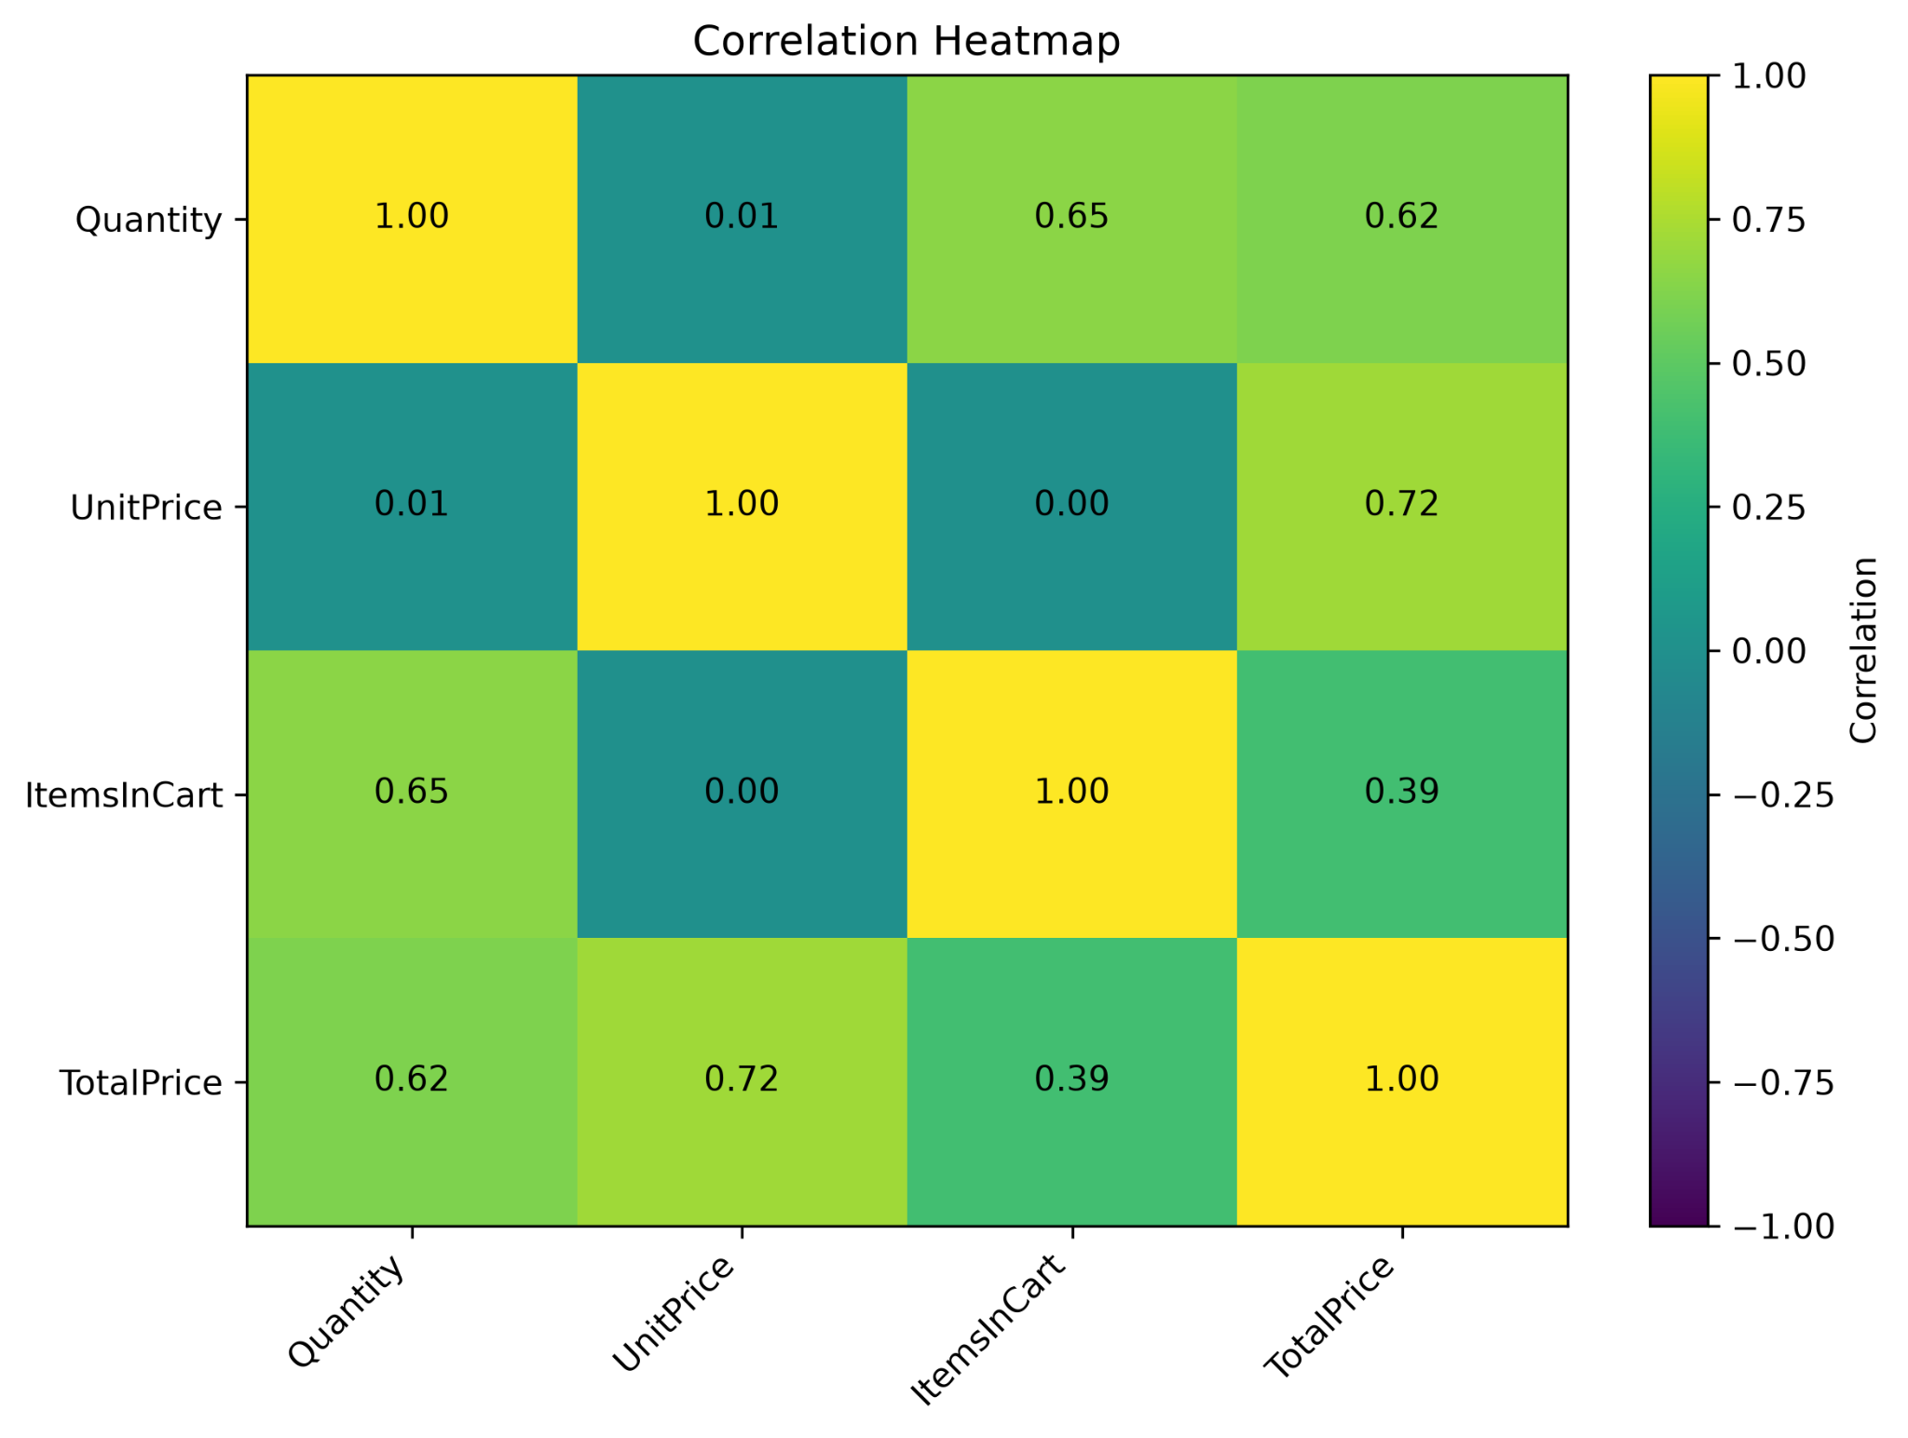
The heatmap shows a positive correlation of 0.72 between UnitPrice and TotalPrice, 0.65 between Quantity and ItemsInCart, 0.62 between Quantity and TotalPrice, and 0.39 between ItemsInCart and TotalPrice. UnitPrice has almost no displayed correlation with Quantity (0.01) or ItemsInCart (0.00). These are associations, not proof of causation.
Box Plot of Quantity
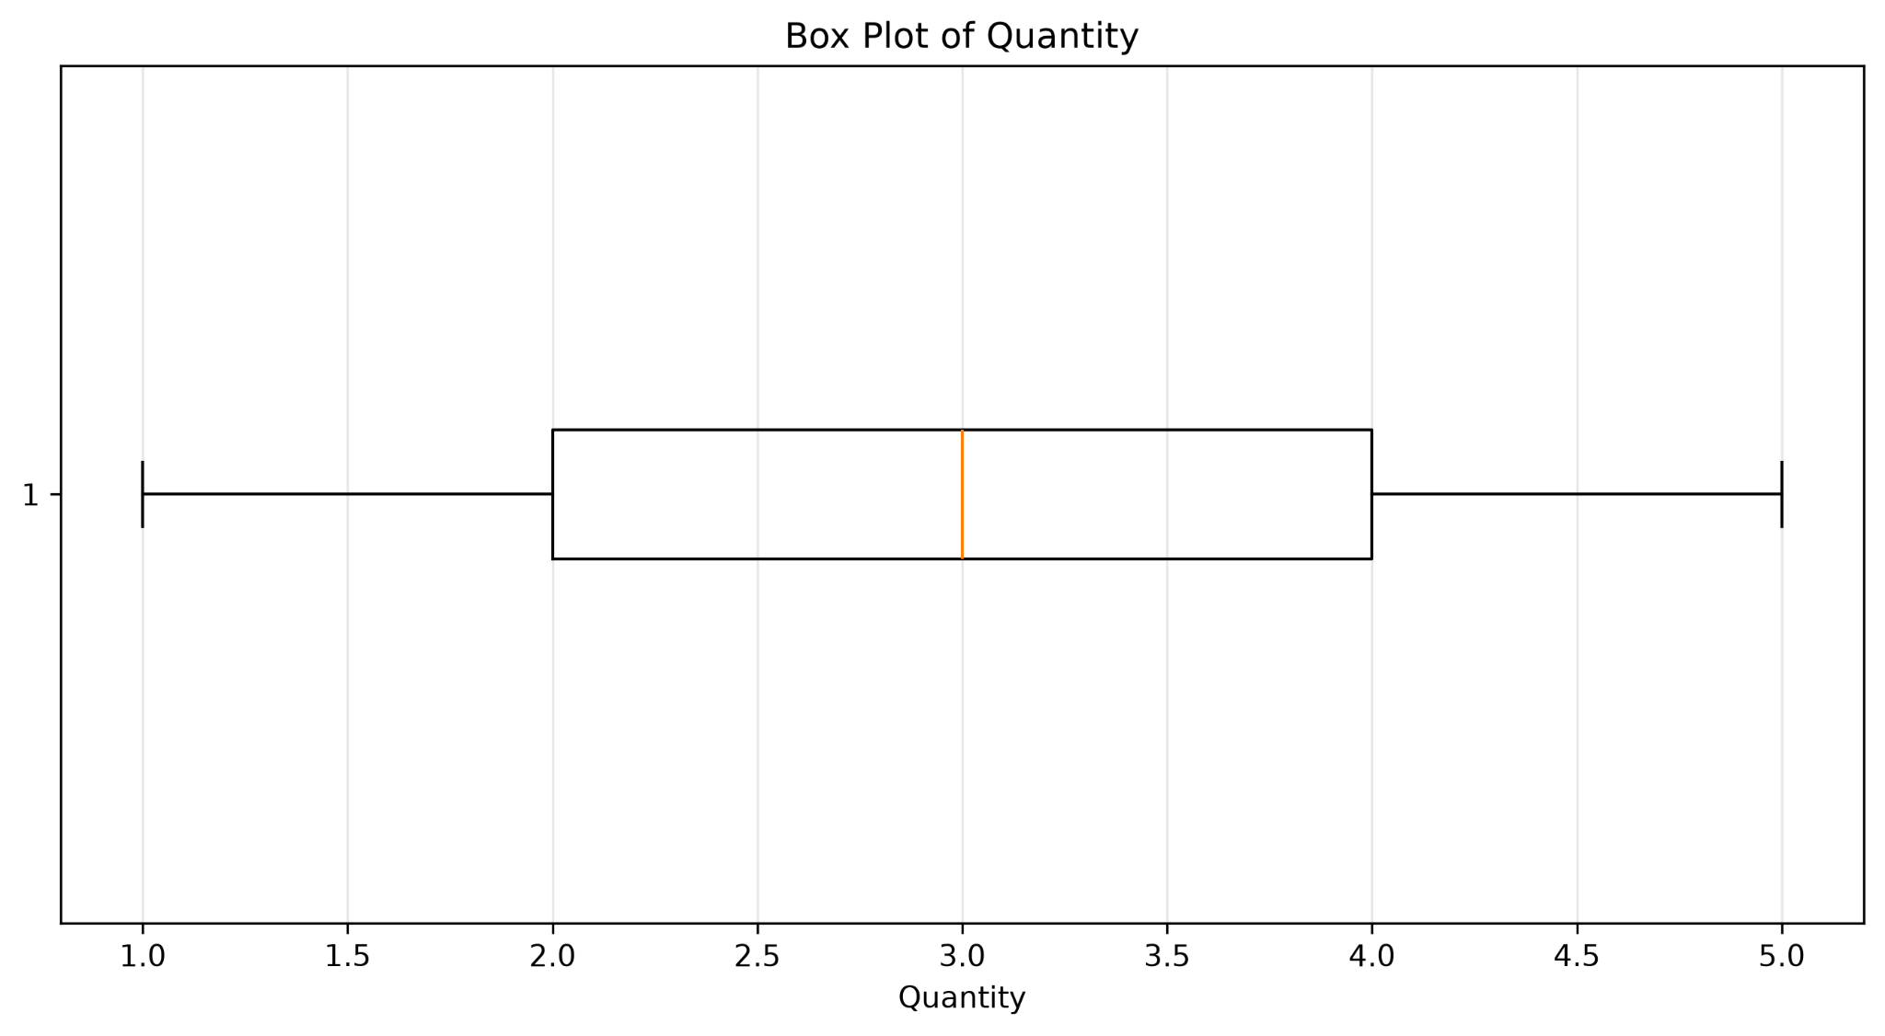
The middle 50% of Quantity values is approximately between 2 and 4, with a median near 3. The displayed whiskers extend from about 1 to 5, and no individual outlier points are shown. This is consistent with the supplied IQR outlier count of zero.
Box Plot of UnitPrice
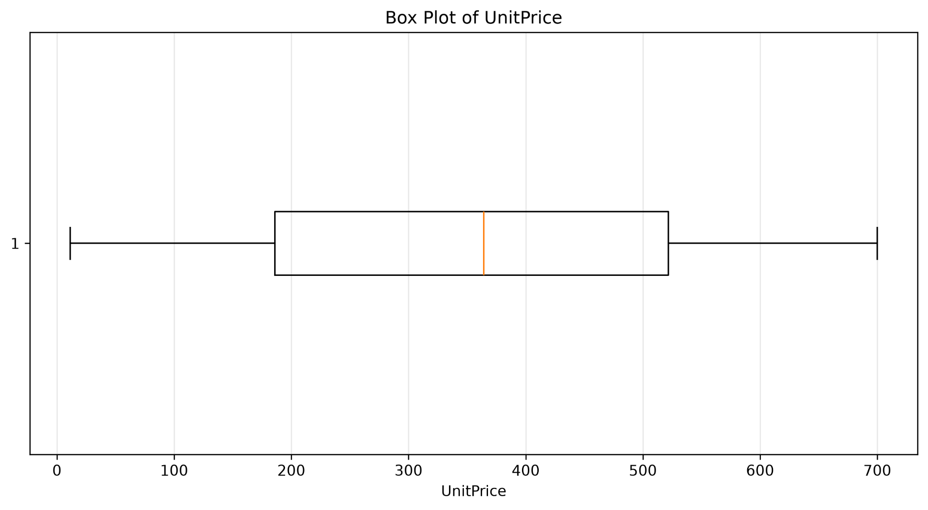
UnitPrice has a wide spread, with the middle half roughly between 186 and 522 and a median around 365. No outlier points are displayed under the chart's box-plot rule; the IQR summary also reports zero potential outliers.
Box Plot of ItemsInCart
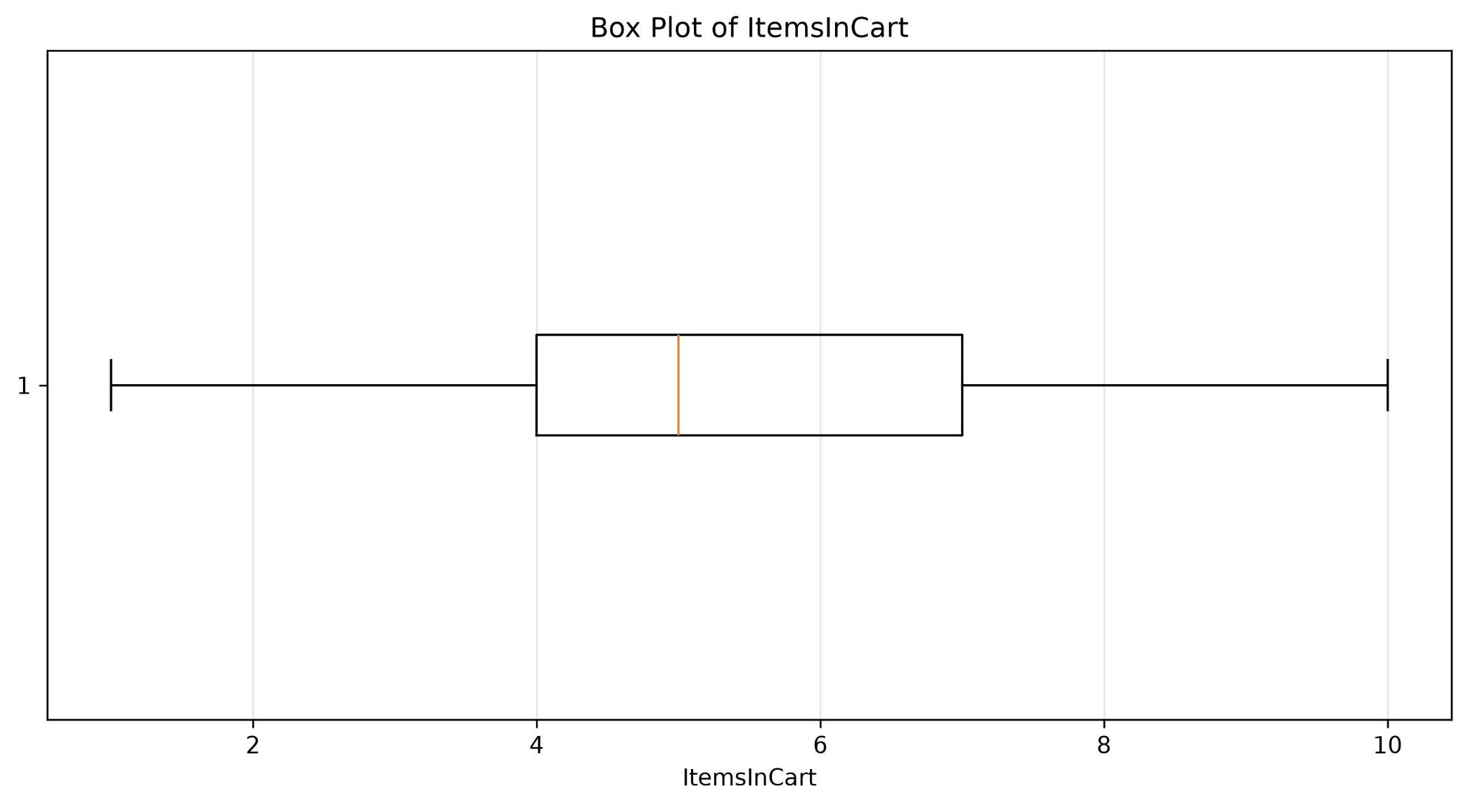
ItemsInCart has a median near 5, with the middle 50% approximately between 4 and 7. The whiskers span about 1 to 10, and no outlier points are displayed. The IQR summary reports zero potential outliers.
Box Plot of TotalPrice
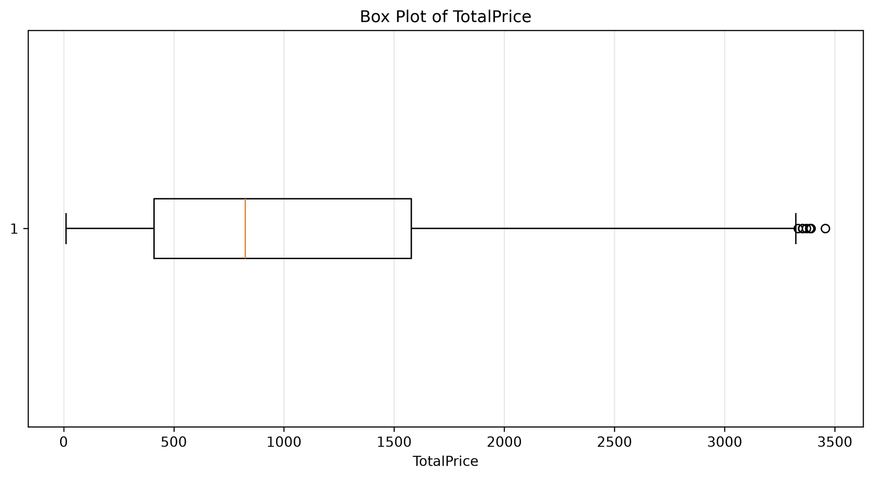
TotalPrice is right-skewed: the upper whisker extends far beyond the median and several high-value points appear beyond the whisker. The supplied IQR summary flags 8 records above the upper bound. Validate these transactions rather than removing them automatically.
7. Bivariate Analysis and Relationships
7.1 Numerical relationships
The correlation matrix is useful for screening relationships among numerical fields. The strongest displayed association is UnitPrice with TotalPrice (r = 0.72). Quantity is also positively associated with TotalPrice (r = 0.62). The positive association between Quantity and ItemsInCart (r = 0.65) may reflect how cart size and ordered quantity move together. UnitPrice is effectively uncorrelated with Quantity (r = 0.01) and ItemsInCart (r = 0.00) in this dataset.
7.2 Product, payment, order status, and referral comparisons
The supplied categorical charts compare sales or order counts across groups. Product-wise and referral-source charts use TotalPrice, whereas payment-method and order-status charts use order counts. These metrics should not be compared as if they measure the same outcome. A useful next step is to calculate revenue per order, cancellation/return rate by product, and conversion or return on ad spend by referral source.
7.3 Monthly trend
From the underlying workbook, the highest monthly TotalPrice occurs in 2024-06 (68,068.54), and the lowest occurs in 2023-04 (27,751.71). Monthly totals can be affected by the number of records per month, large orders, and changes in the mix of products or order statuses.
8. High TotalPrice Outlier Review
The supplied outlier-record extract contains the following eight records. Values are shown as provided in the project output.
OrderID | Product | Quantity | UnitPrice | TotalPrice | OrderStatus
ORD200107 | Printer | 5 | 670.75 | 3,353.75 | Shipped
ORD200326 | Laptop | 5 | 670.48 | 3,352.40 | Returned
ORD200328 | Tablet | 5 | 674.04 | 3,370.20 | Cancelled
ORD200469 | Chair | 5 | 676.98 | 3,384.90 | Cancelled
ORD200632 | Laptop | 5 | 678.16 | 3,390.80 | Delivered
ORD200789 | Tablet | 5 | 691.28 | 3,456.40 | Delivered
ORD201065 | Printer | 5 | 666.80 | 3,334.00 | Delivered
ORD201122 | Monitor | 5 | 678.19 | 3,390.95 | Returned

These records have Total Price values above the reported IQR upper bound. They also have quantities of 5 and unit prices in the upper range of the dataset. Since TotalPrice is consistent with Quantity × UnitPrice for these examples, they may be legitimate high-value orders. Check order details, returns/cancellations, and pricing rules before deciding how to treat them in downstream models.

9. Key Findings
- The workbook contains 1,200 records and 14 columns.
- The supplied data-quality report records 309 missing cells and 0 completely duplicated rows.
- The supplied IQR summary flags 8 potential outliers in TotalPrice and none in Quantity, UnitPrice, or ItemsInCart.
- Chair and Printer are the leading products by displayed total sales; Phone is lowest in the supplied product chart.
- Instagram leads the supplied referral-source sales chart; Referral is lowest.
- Online is the most common payment method in the supplied order-count chart.
- The displayed monthly sales series is volatile, with a notable peak around June 2024.
- The strongest correlation shown is UnitPrice versus TotalPrice (0.72); correlation does not prove cause and effect.
10. Recommendations
- Document every cleaning decision, especially how missing CouponCode values are interpreted.
- Validate duplicate OrderIDs separately from completely duplicated rows; multiple line items can legitimately share an order identifier.
- Confirm date parsing and numeric conversion results, then rerun missing-value and validation checks on the final exported dataset.
- Review the eight high TotalPrice records against source transactions; do not remove legitimate high-value orders simply because they are statistical outliers.
- Track monthly sales together with order counts and average order value to distinguish growth in volume from changes in order size.
- Evaluate product performance using both revenue and margin, not revenue alone.
- Evaluate referral channels using conversion rate, marketing cost, and customer acquisition cost, not sales totals alone.
- Separate completed, cancelled, and returned orders when reporting realized revenue, using an explicitly documented business rule.
- For deeper bivariate analysis, add box plots of TotalPrice by Product, PaymentMethod, and OrderStatus, plus cross-tabulations of OrderStatus by PaymentMethod.

11. Conclusion
The project combines data-quality review with exploratory analysis of ecommerce order records. The ten supplied charts reveal variation in monthly sales, differences across product and referral categories, a relatively balanced order-status distribution, and a right-tailed TotalPrice distribution with eight potential IQR outliers. The correlation heatmap highlights positive associations between price and total price, and between quantity-related measures. The next stage should focus on validating business rules, documenting treatment of missing data and outliers, and adding performance metrics that separate order volume, realized revenue, and marketing efficiency.

